**Table of contents**

Introduction………………………………………………………………………………………………………………...2

Iterative vs direct methods…………………………………………………………………………………………..3

Alternative equation…………………………………………………………………………………………………….4

Performance………………………………………………………………………………………………………………..5

Summary……………………………………………………………………………………………………………………..6

1. Introduction

The aim of this project was to implement and analyze selected numerical methods for solving systems of linear equations. Specifically, two iterative methods (Jacobi and Gauss-Seidel) and one direct method (LU factorization) were implemented and tested. The test systems are based on large banded matrices, which are common in real-world engineering and physical problems such as structural analysis, fluid dynamics, wave propagation, and thermal simulations. Each method was evaluated in terms of convergence, accuracy, and computational performance. The results were visualized with plots and discussed comparatively.

Linear equations were defined by the expression Ax = b, where A represents the coefficient matrix, x is the vector of unknowns, and b is the vector of constants (also called the excitation or right-hand side vector). The goal of the numerical methods implemented in this project is to find the solution vector x that satisfies this equation

I constructed a square matrix of size N × N (where N = 1239), with the main diagonal filled with the value 13, and the diagonals directly above and below it filled with -1. The vector b was of size N × 1, where the n-th element was calculated as sin(n × (f + 1)), with f equal to 7.

 

2. A comparison of iterative and direct methods for solving systems of linear equations

|  |  |  |  |
| --- | --- | --- | --- |
| **Method** | **Iteration Count** | **Time(s)** | **Precision** |
| Jacobi | 23 | 32 |  |
| Gauss-Seidel | 16 | 21 |  |
| LU factorization | - | 445 |  |

For this particular matrix, the Gauss-Seidel method outperformed the Jacobi method in both time and iterations to achieve the desired precision. However, LU factorization proved to be the most precise, reaching a precision ofin 445 seconds. Analyzing the iterative methods, the Gauss-Seidel method required 16 iterations and only 21 seconds to achieve the desired precision, while the Jacobi method needed 23 iterations (+43%) and 32 seconds (+52%) to reach a similar level of precision compared to Gauss-Seidel.

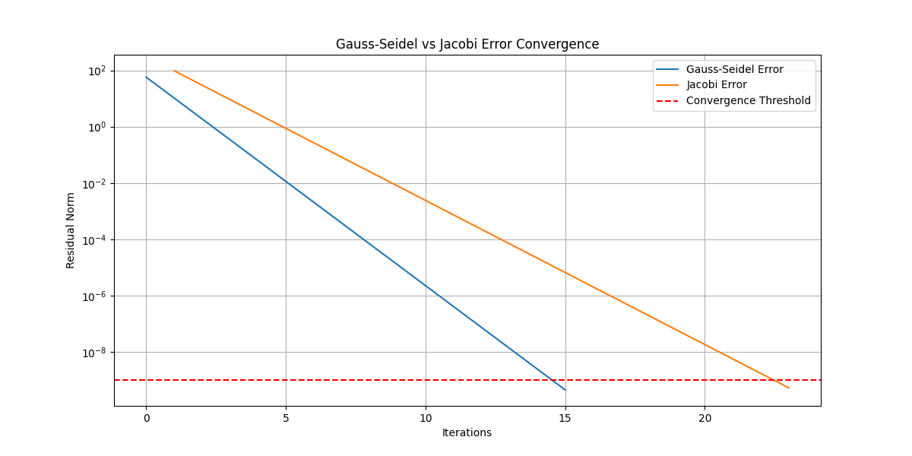

Figure 2.1: Comparison of the iteration-dependent residuum norm for Jacobi and Gauss-Seidel methods

3. Comparison of alternative systems of equations

Now, compare the output by changing main diagonal from 13 to 3, leaving everything else unchanged.

|  |  |  |  |
| --- | --- | --- | --- |
| **Method** | **Iteration Count** | **Time(s)** | **Precision** |
| Jacobi | 59 | 83 | 1088900175 |
| Gauss-Seidel | 25 | 33 |  |
| LU factorization | - | 451 |  |

This time, the iterative methods (Jacobi and Gauss-Seidel) did not achieve convergence. This is due to the fact that the diagonal values are no longer dominant in the matrix.

For iterative methods to converge, the matrix needs to satisfy the condition of diagonal dominance, meaning that the absolute value of each diagonal element must be greater than or equal to the sum of the absolute values of the other (non-diagonal) elements in the corresponding row.

Formula:

Proof: Checking the fifth row, we have the values -1, -1, 3, -1, -1. These values do not satisfy the formula, as .

By changing the main diagonal value from 13 to 3, we reduced the dominance of the diagonal elements, which in turn disrupted the convergence criteria. In such cases, the iterative methods struggle to make progress toward the solution, as the influence of off-diagonal elements becomes comparable to or greater than the diagonal, preventing the method from converging. This issue highlights the importance of diagonal dominance for the stability and effectiveness of methods like Jacobi and Gauss-Seidel. Without diagonal dominance, these methods may fail to converge or may require significantly more iterations to approximate a solution.

On the other hand, LU factorization, although much slower in terms of execution time, was able to correctly solve the system of linear equations. In LU factorization, matrix A is decomposed into the product of two matrices: a lower triangular matrix (L) and an upper triangular matrix (U). Once this decomposition is performed, the system of equations can be solved efficiently by first solving the system for y, and then solving for x. While LU factorization is computationally expensive and requires more time, it is guaranteed to provide a correct and exact solution for the system of linear equations, regardless of the properties of the matrix. This makes LU factorization a reliable choice, particularly for systems where iterative methods may fail.

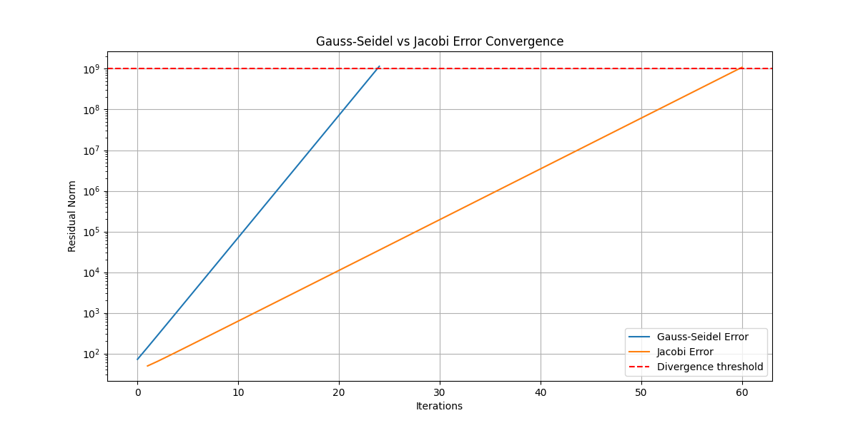

Figure 3.1: Comparison of the iteration-dependent residuum norm for Jacobi and Gauss-Seidel methods

4. Measuring performance

The performance will be evaluated by varying the matrix size, . For each of these matrix sizes, the diagonal value was set to 13 (as initially), and all the matrices achieved convergence.

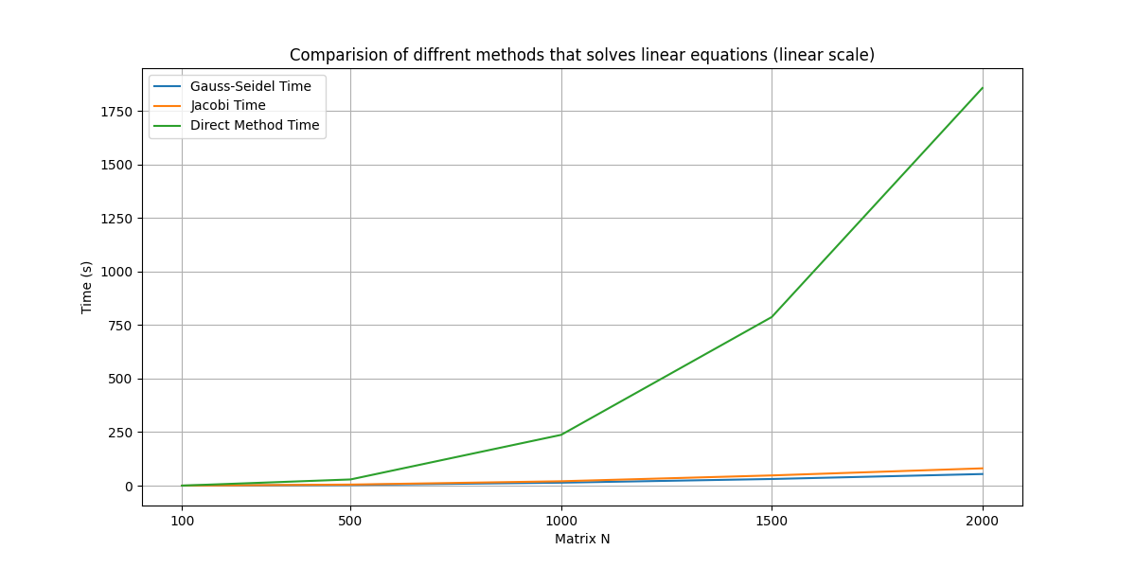

Figure 4.1: Comparison of computation times for different matrix sizes using Jacobi, Gauss-Seidel, and direct methods on a linear scale.

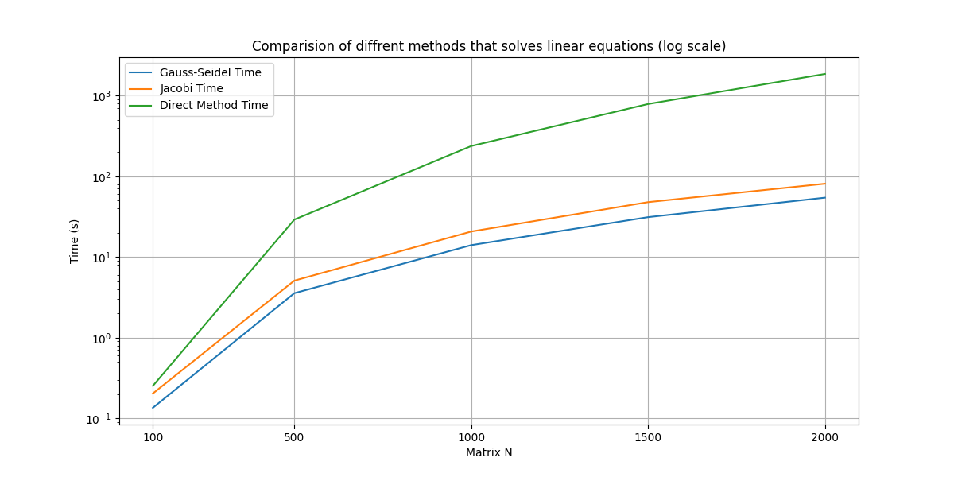

Figure 4.2: Comparison of computation times for different matrix sizes using Jacobi, Gauss-Seidel, and direct methods on a logarithmic scale.

5. Summary

In this project, we compared two iterative methods, Jacobi and Gauss-Seidel, with one direct method, LU factorization, for solving systems of linear equations. The methods were tested on large banded matrices, which are typical in engineering and scientific applications. Gauss-Seidel generally outperformed Jacobi, requiring fewer iterations and less time to achieve the desired precision. However, LU factorization was the most accurate method, providing a precision of , though it took significantly more time to compute. When the main diagonal value of the matrix was changed from 13 to 3, the iterative methods failed to converge, highlighting the importance of diagonal dominance for these methods. This change reduced the dominance of the diagonal elements, disrupting the convergence of both Jacobi and Gauss-Seidel. In contrast, LU factorization was able to handle this change and provide the correct solution, despite the longer computation time. Performance analysis showed that iterative methods scaled well with increasing matrix sizes, but their efficiency dropped when the matrix properties were less favorable. LU factorization, although slower, proved more reliable, making it a better choice for systems requiring high precision. Overall, this project emphasized the trade-offs between computational efficiency and accuracy, illustrating that the choice of method depends on the specific characteristics of the system being solved

Key Takeaways:

1. Use Gauss-Seidel when computational speed is important: This method converges faster than Jacobi and works well for large matrices when the matrix satisfies diagonal dominance.
2. Use Jacobi when simplicity is required: Although slower and less efficient, Jacobi is easier to implement and can be useful for parallel processing scenarios where each iteration is independent.
3. Use LU factorization for high accuracy and stability: While slower, LU factorization guarantees precise results and is ideal when accuracy is crucial, especially in systems where iterative methods fail to converge.